|  |  |  |  |
| --- | --- | --- | --- |
| Department of Engineering  2020-2021 | | |  |
| ***VLC transceiver system encompassing LI-FI and implementing quadrate amplitude modulation.*** | | | |
| Name | Student ID | Course | |
| **Unisa Bangura** | 17000873 | BEng (Hons) Electrical and Electronic Engineering. | |

Contents

Abstract: 2

Literature Review: 2

Method: 4

Results: 9

Task 1: 9

Task 2: 10

Task 3: 11

Task 4: 13

Discussion: 17

Task 1: 17

Task 2: 17

Task 3: 17

Task 4: 18

Conclusion: 19

References: 20

Appendices: 21

# Abstract:

Within this report, a complete design has been simulated using both MATLAB and MultiSim for a visible light communication system. Using the given parameters (Appendix 3), a VLC link at system level was created and a signal to noise ratio was determined (**24.36dB**). Using this data, a VLC transmitter encompassing a white LED was simulated which provided an optimum bandwidth (**1.825MHz**). Finally, with this bandwidth derived, quadrate amplitude modulation was implemented to achieve my targeted data rate and ultimately improve the bit-error rate performance. Filter techniques were also explored for greater data transmission accuracy. This information was then critically analysed for greater understanding of the systems performance.

# Literature Review:

Within this review of published work, I explain how the research conducted supports and serves direct relevance to conclusions drawn later in the report, it also helped form the basis for the theory behind the project.

As the system was encompassing Li-Fi and using visible light communications to meet the required data communication parameter understanding the electromagnetic spectrum was vitally important. Figure 1 illustrates the section of the spectrum which my VLC system would be utilising as can be seen it occupies from 380nm to 750nm equivalent to a frequency spectrum of 430THz to 790THz. VLC is one of the promising candidates because of its features of non-licensed channels, high bandwidth and low power consumption(Latif Ullah Khan, 2017).

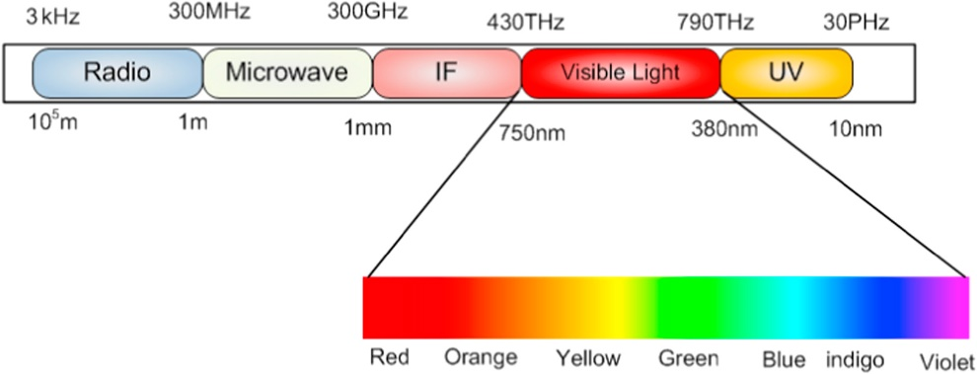

**Figure 1**

A Li-Fi system can employ either an LED or LD to transmit the signal meaning optical based photo-receivers are required to detect this light signal, hence providing the transceiver required to transmit data the same as a traditional RF system. However not all LED’s are appropriate for VLC, there are certain requirements of parameters such as the output power, the semi-angle of the LED, switching time and bandwidth which need to be of appropriate levels. Solid state lighting devices such as gallium nitride (GaN)-based inorganic light emitting diodes (LEDs) are ubiquitous power-efficient devices to enable illumination and communications. Commercially available LEDs have a limited frequency response due to the yellow phosphor coating on top of the blue LED chips (IEEE, 2016). From this research I have conducted I now understand that the LED I require needs to have a high output power and a large bandwidth. It will also most likely be a semiconductor material enabling the deice to turn on and off millions of times per second enabling the diode to send data quickly (Geer, 2017). With this considered I now was aware that for the design of my optical transmitter I would be heavily concerned with the dynamic range of the LED I was using (NSDW570GS-K1), this would in turn give me a greater understanding of the linear region of the device for its optimum operating capability. The image below (Figure 2) illustrates how finding this optimum operating region will produce the desired output signal without data loss due to signal clipping.

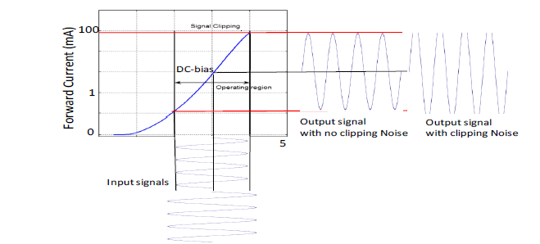

**Figure 2**

Finding this linear region would mean I could select the most suitable component values within my driver circuit and modulator.

Selecting and understanding a modulation scheme for transmitting and receiving the data within this project was the next stage, most commonly the electromagnetic waves are modulated using either their amplitude, phase or frequency. Quadrate amplitude modulation was the method I opted to use, this was because of its ability to significantly enhance the data rate and capacity of wireless communication in comparison with other modulation schemes. QAM is a signal in which two carriers shifted in phase by 90 degrees (i.e. sine and cosine) are modulated and combined (Notes, 2020). Usually the two signals are dubbed ‘Q’ and ‘I’ this is because one signal is in-phase and the other is the quadrate. One of the most important concepts to better understand QAM is constellation diagrams, different locations are allocated values meaning a single signal can have a much higher rate of data transmission. Shown below is a constellation diagram (Figure 3) for a 16QAM signal illustrating the various positions and how they are most commonly arranged in the square gird.

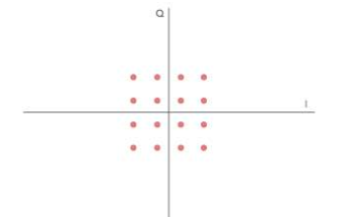

**Figure 3**

The example above is deploying a 16QAM constellation, more bits per symbol is achievable with this method of modulation however there is a trade off because as the level of QAM is increased the constellation becomes more crowded and is more vulnerable to a lower signal to noise ratio and higher bit-error rate.

# Method:

The first task I undertook was to carry out SNR analysis using MATLAB, conventional RF channels have a signal-to-noise ratio which is directly proportional to the average received power. However, for VLC systems it is calculated using the equation below (Eq.1): where Rb is the bit rate (bits/s) or data rate and N0 is the total noise of the system.



**Equation 1**

From this analysis it will provide vital information regarding performance characteristics such as achievable data rate, achievable BER and channel capacity. The SNR parameter which I am considering for this VLC system is a SNR at the receiver greater than 15dB.

To carry out my SNR analysis I simulated a LIFI system using MATLAB consisting of a transmitter (Tx) and receiver (Rx) frontend. As mentioned previously, I am required to work under technical parameters which will directly affect the variables I need to implement in my code, these include: the room dimensions of 10m x 10m x 4m, the LED transmit power between 10-20Watts and the photodiode responsivity between 0.5-0.83A/W. The code I executed can be found in *Appendix 1*.

I decided to deploy a MIMO system to meet the technical SNR requirement throughout the whole room whilst also being conscious of cost ensuring I am not using excess transmitters were not required. Through careful deliberation, I decided to deploy four transmitters (Tx) in a squared formation the rationale behind this being that any receiver will be within a 2.5m radius from any transmitter ensuring there will be the required SNR at any point within the room. The formation of transmitters discussed above can be seen in a 2D and 3D view in the results section (Figure 7/8) illustrating how the LIFI infrastructure would appear in the room. Within the results section is two bar charts, one proving the desired SNR will be achieved at any receiver (Graph 1) and a second which demonstrates the received power at each Rx from every Tx (Graph 2).

For the second task I completed a Multisim design/schematic for the VLC transmitter, with a goal of finding the LED dynamic range, I then could use this for my modulator circuit design. Allowing me to be able to select specific values for the components within the circuit for my optimum design.

This was achieved by using a simple resistor diode circuit which can be seen below (Circuit 1):

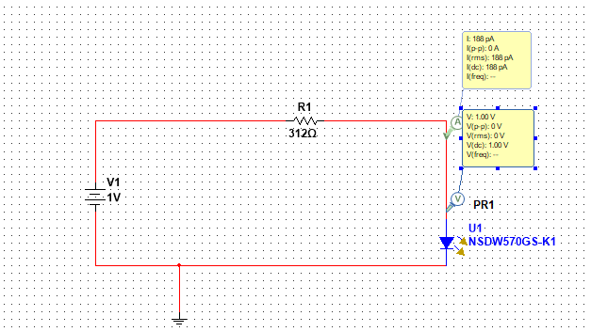

**Circuit 1**

The resistor value was set to 312Ω to avoid damaging the LED as the maximum forward current it can cope with is 80mA as can be seen on the LED(NSDW570GS-K1) data sheet in Appendix 4. Therefore, the resistor value was set to this level to limit the forward current to 70mA and the power supply to a maximum of 25 volts. This can be verified using ohms law: R = V/I hence 25V/80mA = 312.5Ω. Using Circuit 1, I carried out a DC sweep on the voltages from 1-25V which would obtain me the forward voltage and current of the LED and from this I could study the non-linearity of the LED and find the I-V characteristics to acquire the optimum DC bias point. The resultant table can be found (Table 1) in the results section. With this table created I could use the MATLAB software to plot the information on a graph to visually represent the date for easy interpretation, this can also be found within the results section (Graph 3).

With this information acquired, I could now move onto the next step using the optimal forward current (IDC) for the design of the driver circuit and modulator for the LED. The circuit was designed within the MultiSim software and can be seen below (Circuit 2):

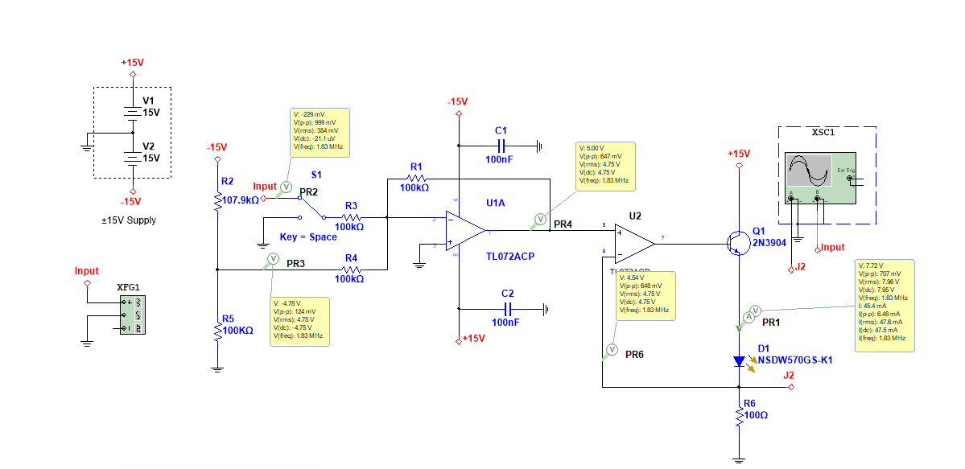

**Circuit 2**

With the optimal IDC for the LED of 47.5mA calculated, I could now begin to optimize the required forward DC current and voltage by choosing appropriate resistor values. The voltage at the output terminal of the summing amplifier in the above circuit is the inverted sum of the two voltages at the input terminals. This is calculated using each input voltage multiplied by a particular gain value derived from R1/R3 and R1/R4, hence the equation:

With this equation known the circuit can then be simplified by making R1, R3 and R4 an equal resistance value resulting in the simplified equation of:

Next, I needed to derive the potential divider networks resistor values which provides the Vbias input voltage to the summing amplifier. Before this could be done the second amplifier (transconductance) needed to be satisfied to bias the LED into its linear region. To achieve this, the output of an op amp is used to drive an NPN bipolar transistor, which in turn boosts the current output capability of the op amp itself (Keim, 2016). The circuit above shows that the current through the diode is directly affected by the voltage inputted into the amplifier (U2) and the value of R6, hence a simple ohm’s law calculation of:

Rearranged to make Vbias the subject:

Now with values derived for Ibias, Vbias and resistors 1,3,4 and 6 we were left with only two unknowns to complete the circuit (R2&5). As mentioned previously this was the potential divider network which was found using the equations below assuming the value of R5 to be equal to R4:

Now inserting the value above into the final equation to find the last unknown of R2:

With resistor values found I could now begin AC analysis of the circuit with the goal of having a better understanding of the bandwidth of the system. This was completed using two methods for verification purposes, the first via manually changing the frequency of the signal input using the function generator within the MultiSim software and the second by employing the AC sweep function also within Multisim to analyse the bandwidth.

The table in the results section (Table 2) illustrates the results determined by altering the input signal frequency using the function generator and recording the voltage peak-to-peak to achieve the required gain of -3dB using the formula 20Log10(VP-P) = gain(dB).

Hence from the table my bandwidth frequency was obtained, and I could now verify my results using a second method for complete accuracy. This was completed by using the AC sweep function within Multisim, the first sweep I conducted (Graph 3) was at a starting frequency of 1Hz to a stop frequency of 6MHz on a linear vertical scale. This was an indicator that the y-axis was in fact plotting Vp rather than the desired VP-P so for the 1st sweep I was looking for the point of 0.3535V (0.707V/2). For the second sweep which would in fact prove I had derived the correct bandwidth was from the same start/stop frequency but of a Decibel vertical scale instead (Graph 4). With this fact known regarding the y-axis scale, the point I aimed to find was 20Log10(0.707/2) equalling -9.03dB. Both graphs can be found in the results section with further explanation.

With analysis of the optical transmitter circuit completed and its bandwidth determined I could now utilise this knowledge for my QAM modulator to set its QAM level and data rate. I determined my QAM level from the bandwidth frequency and the number of bits per signal, because I had a required data rate of 5-8Mb/s I decided to implement 16-QAM because 1.825MHz multiplied by 4 bits per signal equals 7.3Mb/s which is perfect for the required data rate parameter.

With the QAM level obtained I could now use MATLAB to code the modulation scheme which can be found in Appendix 2. The block diagram below (Figure 4) shows the steps undertaken within the code to achieve this modulation scheme:

Setting QAM parameters:

Firstly, the size of the QAM level was set as well as the number of transmission bits. Basically, just setting parameters at this point calculated as stated above.

Radom Data generation:

Now random data must be generated to simulate a signal, so we have a signal to modulate. The first 20 samples were plotted.

Reshaping binary into an integer value:

Here the data is converted from binary to decimal form, so it is prepared for QAM of the signal.

Signal is modulated using ‘QAMmod’ command: Based off the decimal value it converts into polar form (Z=a+bi) with a real and imaginary part where phase is the angle and amplitude is the magnitude.

Next noise was added to simulate the wireless channel: Here the AWGN function was utilised to add white gaussian noise as if to simulate a real system with added noise.

Demodulation at the receiver: Now the data has been modulated at the transmitter and noise has been added the data can now be recovered using the ‘qamdemod’ command.

After demodulation has occurred the data must be now converted back from decimal to binary.

The data is now recovered after demodulation and a signal is received.

Finally, the BER could be computed using the ‘biterr’ command.

An eye diagram was created for better visualisation of the filter effects.

**Figure 4**

All resultant diagrams and plots can be found within the results section with discussion and analysis.

Now that my QAM coding had been implemented (Appendix 2) and results synthesised I could now analyse the BER Performance of QAM transceiver system as a function of SNR showing the targeted BER. This was fulfilled using a simple ‘For loop’ function within MATLAB and the plotting the SNR vs BER, said code can be seen below (Figure 5):

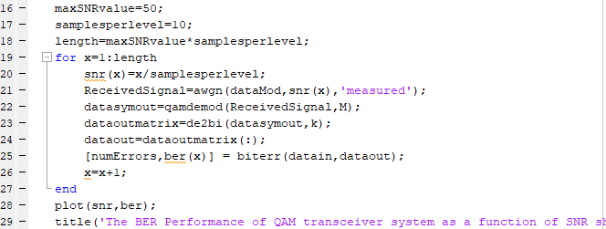

**Figure 5**

The graph can be found within the results section of the report Graph 10.

After this analysis was completed, I felt it was further necessary to try and improve the accuracy and efficiency of data transmission. RRC filtering was the method I decided to employ in favour of other filtering techniques such as LPF and Rect. The root raised cosine filters main aim was to reduce noise at the receiver. The code I used to implement this feature within my design can be found in Appendix 5. Resultant graphs can be found within the results section where the RRC filter has been utilised compared with an unfiltered signal, to analyse the effect of deploying the filtering technique (Graph 11/12/13).

# Results:

# Task 1:

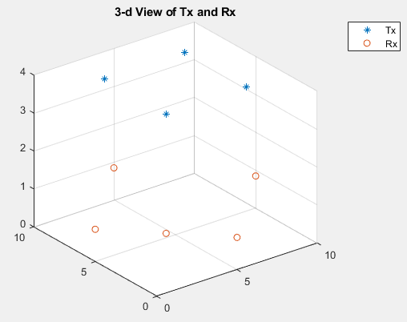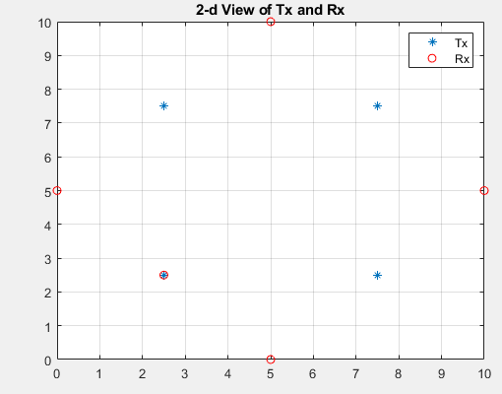(**Figure 7): (Figure 8):**

The graphs above demonstrate the topology of my receivers and transmitters in both a 2-d and 3-d view. It further illustrates how each transmitter provides 2.5m connection radius providing good coverage throughout the entire room.

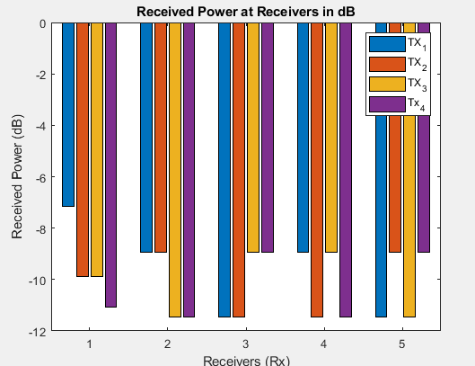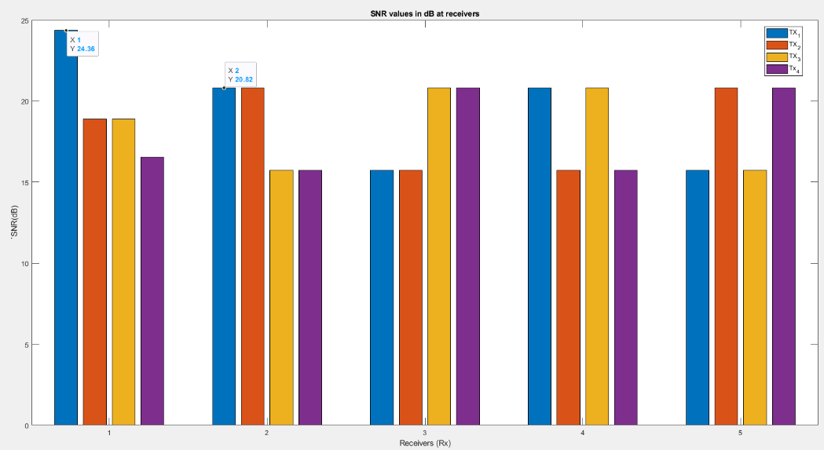**(Graph1): (Graph2):**

The graph on the left illustrates the received power at all receivers and the adjacent graph shows the SNR at each receiver (Rx). This proves that the SNR in LOS of the transmitter is 24.36dB whereas 2.5m away, which is the maximum possible distance any receiver can be from a transmitter it is 20.82dB. This comfortably surpasses the 15dB parameter requirement for my system proving my chosen MIMO infrastructure is fully fit for purpose.

# Task 2:

***(Table 1)***

|  |  |  |
| --- | --- | --- |
| Applied Voltage (V) | Voltage-Current Characteristics | |
| Forward voltage, VDC (V) | Forward current, IDC (mA) |
| 1 | 1 | 188 x 10-9 |
| 3 | 2.54 | 1.48 |
| 5 | 2.73 | 7.27 |
| 7 | 2.83 | 13.4 |
| 9 | 2.92 | 19.5 |
| 11 | 2.99 | 25.7 |
| 13 | 3.05 | 31.9 |
| 15 | 3.11 | 38.1 |
| 17 | 3.17 | 44.3 |
| 19 | 3.23 | 50.5 |
| 21 | 3.29 | 56.8 |
| 23 | 3.34 | 63.0 |
| 24 | 3.37 | 66.1 |
| 25 | 3.39 | 69.3 |

With this results table derived, I could now plot the voltage against the current to find the dynamic range of the LED.

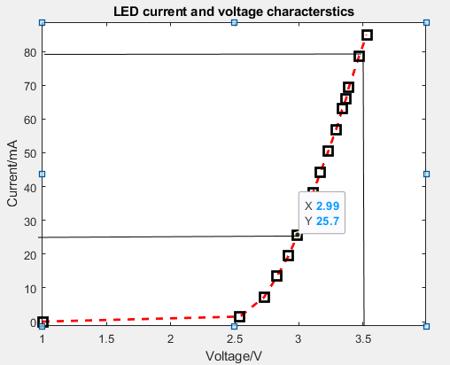***(Graph 3):***

With this graph plotted I could now easily find the linear region of the above I-V curve also known as the dynamic range of the LED (NSDW570GS-K1). This was between 25.7-70mA therefore giving an optimal forward current (IDC) of **47.5mA**.

# Task 3:

***(Table 2):***

|  |  |  |
| --- | --- | --- |
| Frequency (Hz) | VP-P (V) at output (J2) | Gain (dB), 20Log10(VP-P) |
| 10k | 1.09 | 0.74 |
| 700k | 1.01 | 0.086 |
| 1M | 930m | -0.630 |
| 1.5M | 793m | -2.014 |
| 1.75 | 726m | -2.78 |
| 1.825 | 707m | -3 |

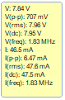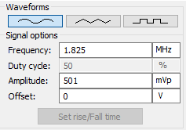As stated in the method this is the resultant graph of altering the input signal frequency using the function generator and recording the voltage peak-to-peak to achieve the required gain of -3dB. Shown adjacent is the function generator signal options to achieve this gain requirement. A sinusoidal waveform at a frequency of 1.825MHz with an amplitude of 501mVp and no offset. Below is the resultant oscilloscope reading for said function generator variables:

**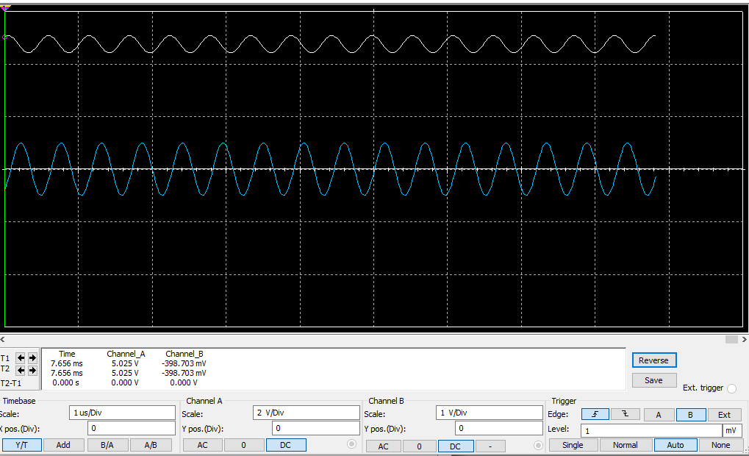*(Graph 3):***

We can see very smooth and concise input and output sine wave, with no signal clipping occurring. However, at this point we can see the output signal is considerably less than the input further proving this is the cut-off region (max frequency bandwidth) of the LED before operation becomes inadequate or less than -3dB gain of the system. The image adjacent is a voltmeter and ammeter reading of the current flowing through the LED clearly achieving the required parameters of IDC = 47.5mA and VP-P = 707mV = -3dB gain.

**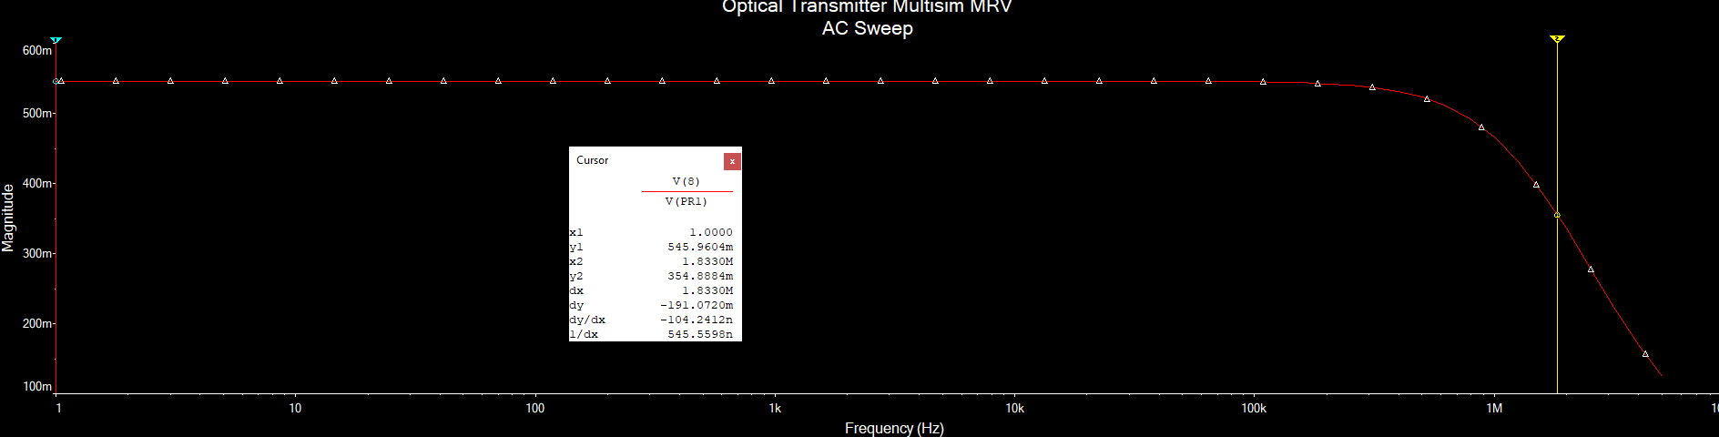 *(Graph 4):***

With the bandwidth required, I felt it was important to verify this result using a second method, as discussed previously I deployed an AC sweep using MultiSim. The above being of a linear vertical scale plotting VP on the y axis. I was looking for the point of 0.3535V (half of the required VP-P of 707mV). As seen above, the bandwidth frequency is 1.833MHz verifying the first methods result.

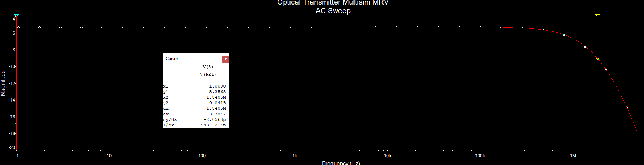***(Graph 5):***

With this new fact known regarding the y-axis plot the next sweep was of a decibel vertical scale, finding the -3dB gain point. The resultant AC sweep above verifies both methods previously deployed of obtaining the bandwidth because -3dB gain point is also at a frequency of 1.84MHz.

With Bandwidth analysis complete I could now use this knowledge for QAM implementation.

# Task 4:

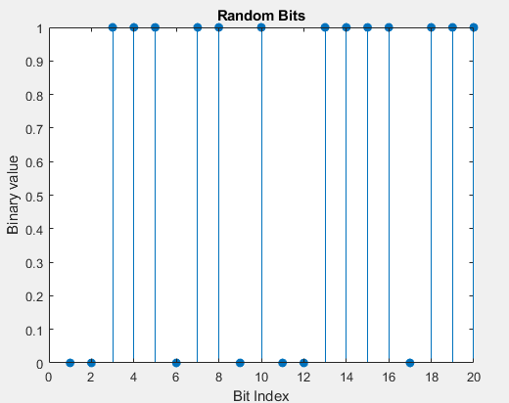As can be seen in step 2 of the block diagram the first 20 samples were plotted and can be visualised on the resultant graph below (Graph 6):

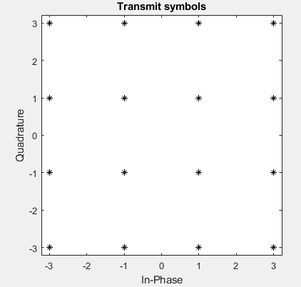After these binary samples were plotted there were reshaped into decimal form, again visualised on the stem diagram below (Graph 7):

After the data had been converted and the signal had been modulated it was then transmitted, shown below is the transmitted data in a 4x4 constellation for my 16-QAM level (Graph 8):

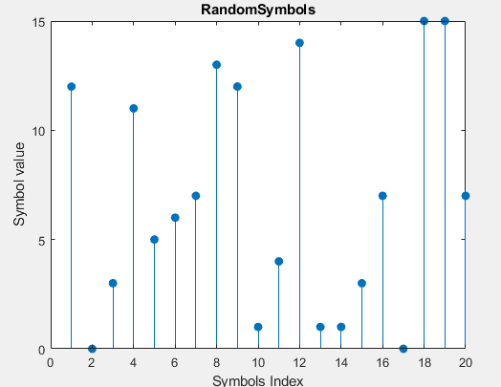

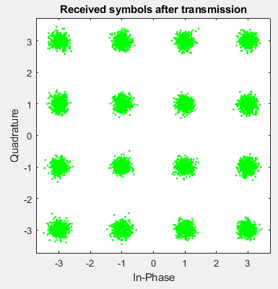After the added white gaussian noise was applied to the transmitted signal to simulate the wireless channel connection, I plotted the received data symbols on the resultant graph below (Graph 9):

From this image we can see the SNR is still very high and of adequate level because the received symbols are easily differentiated meaning is misinterpreted.

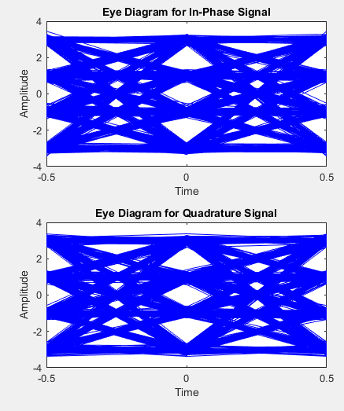With the above constellation diagram for the receiver symbols after transmission plotted, I then implemented a code (Appendix 2) to plot an eye diagram which is displayed below (Diagram 1):

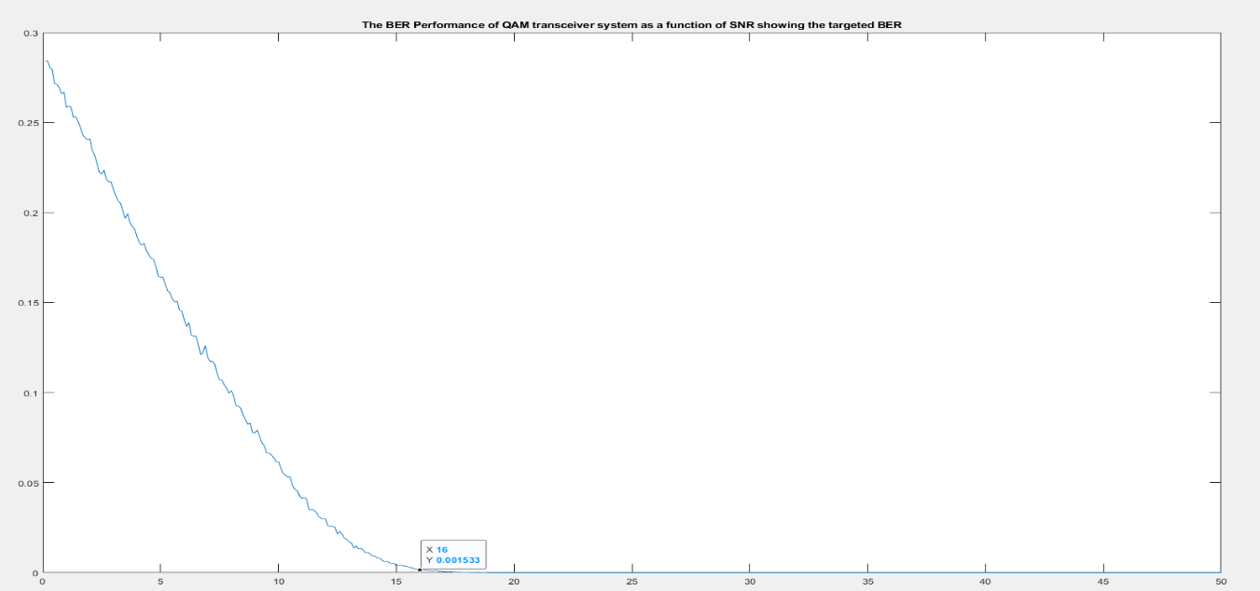From this eye diagram I can infer that the system is experiencing a slight amount of amplitude and time variation however the system still clearly demonstrates the paths of the signal without any significant abnormalities.

**(Graph 10)**

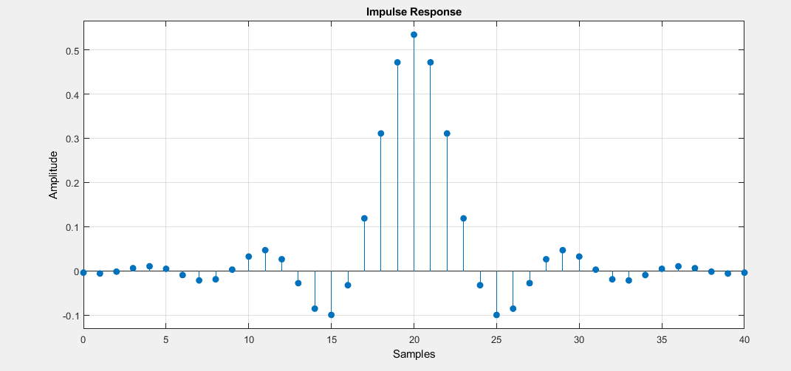Above is the plot of the SNR against BER (Graph 10), the given parameters required a BER less than or equal to 2x10-3 above shows that at 16dB this is achieved, and as clarified above the minimum SNR value possible within the room is 20.82dB. Further proving the suitability of my system design.

Here the random data is simulated before it is modulated using QAM and up sampled by a factor of the SPS using an RRC filter before noise is added. Then after this, it is down sampled and combined resulting in a stronger signal with an increased SNR. The data was then demodulated and plotted in graphical forms for better visual representation below (Graph 11/12/13):

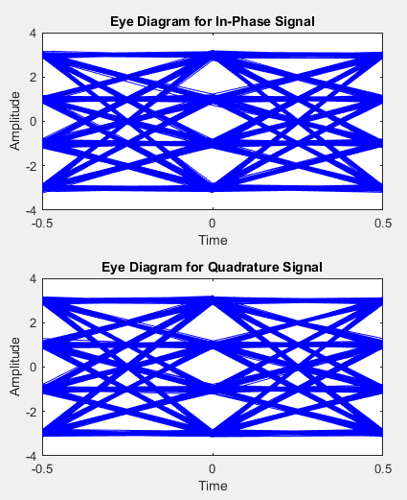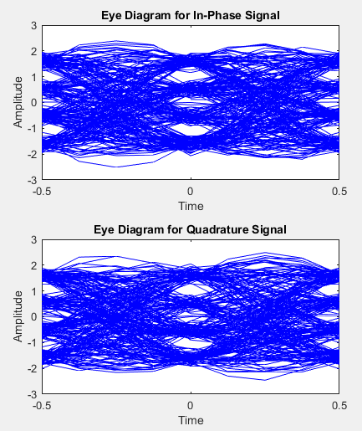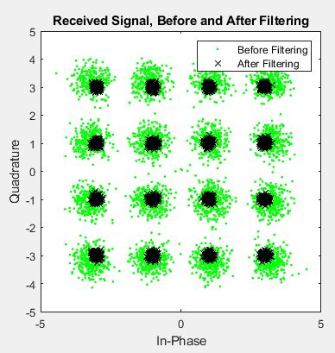

**Graph 11. Graph 12. Graph 13.**

These images above really demonstrate how the RRC filer increases the SNR and reduces the BER of the VLC system. It clearly shows the different received signals in the constellation diagram being much easier to distinguish from one another, illustrated by the black crosses opposed to the green.

# Discussion:

# Task 1:

Simulation of the VLC slink at the system level was the first requirement necessary, as discussed in the method a MATLAB code was implemented (Appendix 1) to carry out this task. Certain parameters (Appendix 3) were to be followed to get the desired result of providing a SNR at the receiver greater than 15dB. A range of 10-20Watts of LED transmission power and photodiode responsivity of 0.5-0.83A/W were suggested for consideration in the brief. After analysis of the above results there seemed to be an obvious trend that as the transmitted power increases the SNR rises also, hence the selection of 20Watts of transmitted power for the LED. With this discovered it left the second selection of photodiode responsivity, according to Dr.Paschotta ‘A photodetector should ideally be operated in a spectral region where its responsivity is not far below the highest possible value, because this leads to the lowest possible detection noise and thus to a high [signal-to-noise ratio](https://www.rp-photonics.com/signal_to_noise_ratio.html) and high sensitivity’ (Paschotta, 2020). With this taken into consideration and trialling minimum and maximum values a photodiode responsivity of 0.83A/W was chosen, as we were trying to provide an SNR greater than 15dB at the receivers. With these two parameters selected and executed into the code along with the correct room dimensions two resultant graphs were plotted (Graph 1&2) and can be seen in the results section. They clearly show the SNR at all receivers comfortably surpassing the requirement, so if you are in LOS of the transmitter the SNR is 24.36dB displaying good interconnection between components. Whereas 2.5m away from a transmitter which is the maximum possible distance any receiver can be from a transmitter with my chosen topology the SNR is 20.82dB. This conformably meets requirements, so I was happy to move onto the next stage of the project.

# Task 2:

This next stage started with some simple analysis of the LED to find the dynamic operating range; which allowed me to derive component values for the modulator circuit (Circuit 2). Once the core data was derived from simulating the various voltages through the Multisim circuit (Circuit 1), a graph was plotted where the dynamic range could be easily interpreted. With a knowledge of the maximum forward current from the LED (NSDW570GS-K1) data sheet (70mA) and being able to view the point where the graph becomes linear. A proven appropriate value of 47.5mA for the optimum forward current (IDC) for the LED was selected. With this value calculated I am happy with the accuracy of equations deployed within the method to decide on suitable component values within my modulator driver circuit.

# Task 3:

With values derived and the circuit operating as desired, I then focused on the analysis of the bandwidth, so I could use it for QAM modulation. I initially opted for a manual AC sweep where I used a function generator to input various different signal frequency until the desired gain was achieved. This gave a result in the region I was expecting so I opted for a second method to verify my answer, this was using the AC sweep function in Multisim. After slight deliberation regarding values plotted on the y-axis, I was confident that the values were on a small enough range of one another to authenticate my results. The manual sweep obtained a bandwidth frequency of 1.825MHz, the linear vertical scale AC sweep resulted in a bandwidth of 1.833MHz and finally the decibel sweep got a value of 1.84MHz.

With the bandwidth value confirmed I could now use it for the implementation of QAM modulation for the given data rate from the parameters (Appendix 3) of 5-8Mb/s and set a QAM level to execute into my code (Appendix 2). Using any one of the methods for retrieving the bandwidth frequency resulted in the optimum QAM level being 16QAM, this is because Log2(QAM level) equals the number of bits per symbol. So, by multiplying this value of 4 for 16QAM by the bandwidth retrieves the data rate of the system which for this system is between 7.3-7.4. Comfortably within the given parameters, again verifying the tasks validity and the suitability of design procedure.

The forward bias current and voltage (I-V) curve for the LED was another important aspect to consider to avoid signal clipping, ultimately preventing the loss of information or unwanted noise. Within the modulator driver circuit, I noticed that as I increased the amplitude (Vp-p) of the input signal it would result in the LED operating outside its dynamic range. This was evident as the sinusoidal waveform would start to be clipped resulting in it looking more of a square shape on the oscilloscope. By applying my derived bandwidth frequency (1.8MHz) along with an input Vp-p of 1V it resulted in a very smooth and desirable input and output signal which satisfied parameter requirements.

# Task 4:

This final task was where I implemented quadrate amplitude modulation using a MATLAB code (Appendix 2). To summarise: Random data was generated, converted to appropriate forms, data was modulated onto the signal, noise was added, the signal was demodulated after experiencing the AWGN and finally I could analyse this process to compute the BER rate of the system and draw conclusions from the resultant plots. One of the most telling and interesting plots was Graph 9, here we could visualise the received signal after it had simulated adding the white gaussian noise as a practical wireless system would experience. From the figure we could clearly see and separate the received symbols and distinguish them from one another, proving the SNR was of an appropriate level.

To evaluate the BER performance of the QAM transceiver system I felt it necessary to plot the signal-to-noise ratio against the bit error rate. This would give me the minimum SNR required at the receivers to result in a BER which satisfies the parameter criteria (≤2x10-3). Graph 10 demonstrates evidence that the minimum SNR to meet said requirement was 16dB, with this knowledge known I was happy that my system design conformably fulfils all obligatory requirements within the brief. This is because even at the point of worse coverage in the room, 2.5m away from a transmitter the maximum possible distance, the signal was still strong enough to translate all data with a bit-error rate of zero.

RRC Filter:

As well as Graph 12 indicating the benefits of the root raised cosine filter, the two eye diagrams (Graph 11/13) really reveal how ISI is reduced. Ultimately showing the filter reducing the unwanted noise on the signal for greater VLC system accuracy.

# Conclusion:

In conclusion of the project, one of my main deduction was that to achieve the requirement of a SNR at the receivers greater than 15dB it relied on receiver positioning within the room. The square formation topology which I have selected is second to none for overall good coverage and system efficiency. This is evident, as even at the furthest point possible away from a transmitter the requirement is fulfilled comfortably. There was a clear trade-off between signal strength at the receiver and power transmission power of the LED because as the power transmitted increased the SNR also increased. So, for the given aims in the brief maximum power was opted for, to result in a maximum signal-to-noise ratio at receivers.

After this, the driver circuit was simulated and component values were selected, I am happy that the correct specifications were chosen to meet the project’s goals. The optimum forward current calculated above was correctly supplied to the LED (NSDW570GS-K1) at 47.5mA.

This then allowed for the maximum frequency bandwidth to be analysed using various methods for improved accuracy, finding a range of 1.825-1.84MHz before the systems response becomes unfit for purpose. With this information acquired led to the selection of the 16-QAM level being implemented to modulate the data upon transmission. The modulation and demodulation were simulated within MATLAB and the resultant information was plotted in a visual form (received symbols and eye diagrams) to illustrate the success of data communication between receiver and transmitter.

After QAM was implemented, I could finally analyse the bit-error rate within the system to determine the overall accuracy of data communication within the visible light optical communication link. Here the BER was found to be zero meaning no anomalies occurred within data transmission and receiving hence proving system suitability and parameter requirement fulfilment.

If I conducted the assignment again, I think the report would benefit massively from practical testing within the lab. I would then be able to compare my theoretical results with this new practical data to improve system performance.

# References:

Latif Ullah Khan. (2016, July). Visible light communication: Applications, architecture, standardization and research challenges, Volume 3, Issue 2, Page 80: <http://www.sciencedirect.com/science/article/pii/S2352864816300335>

Keim, R. (2016, March). *How to Buffer an Op-Amp Output for Higher Current.* Retrieved from All About Circuits: <https://www.allaboutcircuits.com/technical-articles/how-to-buffer-an-op-amp-output-for-higher-current-part-1/>

Paschotta, D., 2020. *Responsivity*. [online] Rp-photonics.com. Available at: <https://www.rp-photonics.com/responsivity.html#:~:text=The%20responsivity%20is%20usually%20defined,frequencies%20above%20some%20detection%20bandwidth.&text=If%20some%20detector%20has%20a,output%20voltage%20and%20optical%20power.> [Accessed 13 December 2020].

Y. Zhou, J. Zhao, M. Zhang, J. Shi, and N. Chi, “2.32 Gbit/s phosphorescent white LED visible light communication aided by two-staged linear software equalizer,” in 10th International Symposium on Communication Systems, Networks and Digital Signal Processing (CSNDSP) (IEEE, 2016), pp. 1–4.

Geer, D., 2017. Li-Fi: High-Speed Communication Via LED Modulation. [online] Architect. Available at: https://www.architectmagazine.com/technology/lighting/li-fi-high-speed-communication-via-led-modulation_o> [Accessed 22 December 2020

Notes, E., 2021. *What Is QAM: Quadrature Amplitude Modulation » Electronics Notes*. [online] Electronics-notes.com. Available at: <https://www.electronics-notes.com/articles/radio/modulation/quadrature-amplitude-modulation-what-is-qam-basics.php> [Accessed 2 January 2021].

# Appendices:

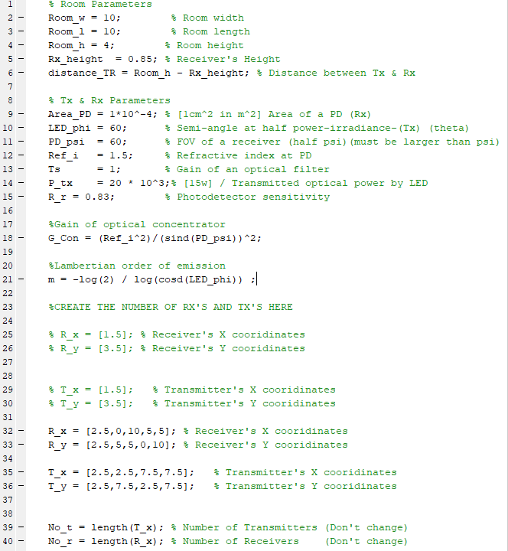**Appendix 1:** VLC code.

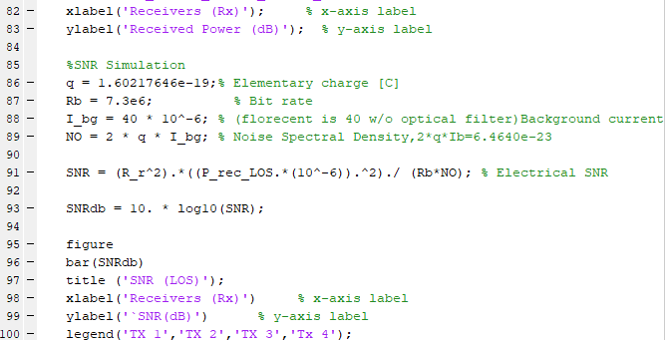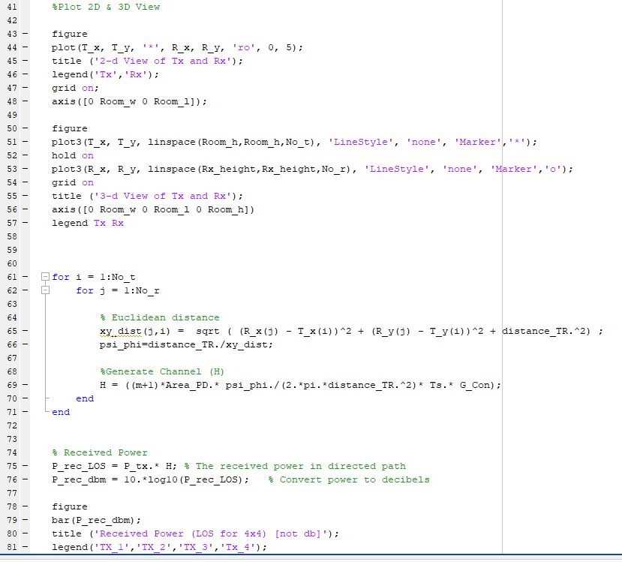

**Appendix 2:** QAM code.

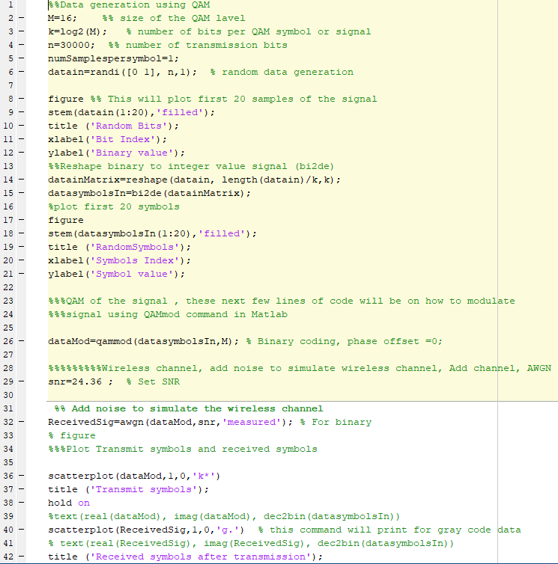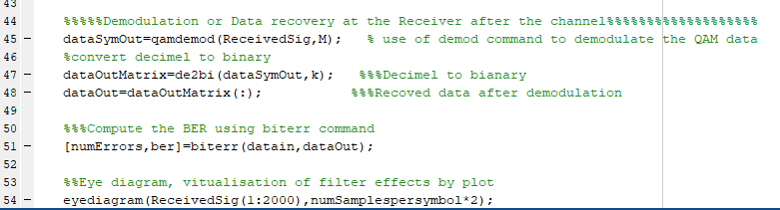

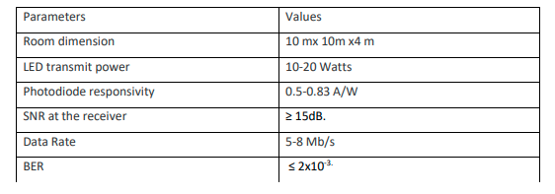**Appendix 3:**

**Appendix 4:** LED data sheet.

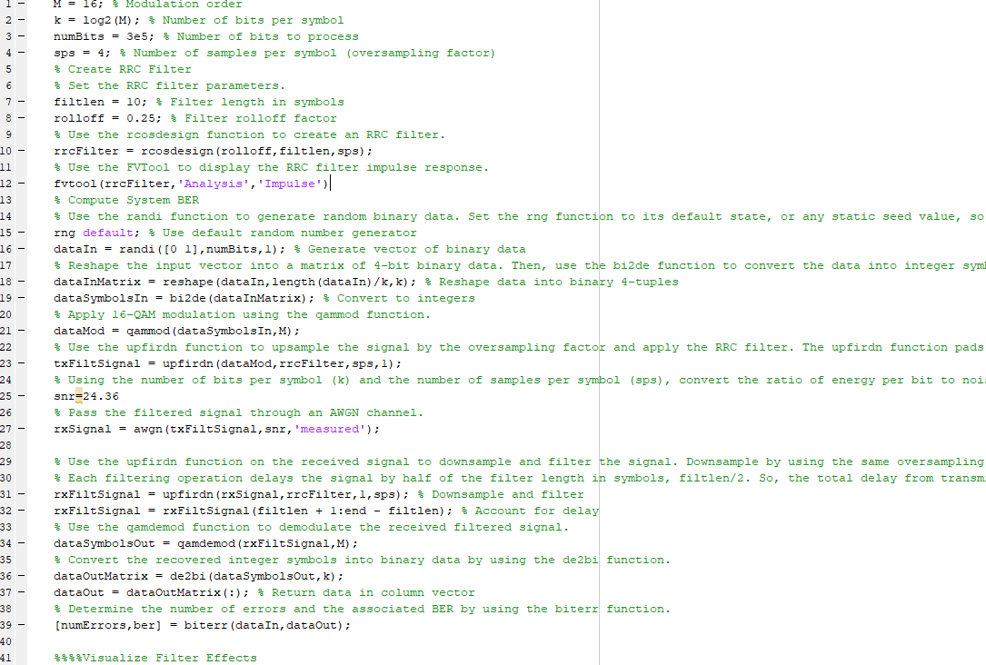**Appendix 5:** RRC filter code.

